JKKW Media

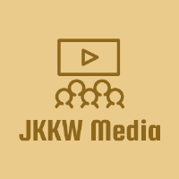

Team captain: Joshua Hughes

Other team members: Kurt Leadley, Karie Funk, Wendy Portillo

**Bios:**

**Karie Funk**

My name is Karie Funk and I am one of the developers on this project. I have a strong passion for designing and developing web pages. I have been practicing my graphic design skills for a long time now and have been working on my web development skills for a few years now. I plan to finish my B.S. in Web Development in fall of 2020 and hope to find an awesome career doing this. While I don’t consider myself as experienced as some developers, I’m willing to learn and put in the time it takes to become a successful web developer. When I’m not on the computer coding, I am usually hanging out with my fiancé, dressing my cat up in ridiculous outfits, listening to music, and reading. I also enjoy cars and the vehicle in my picture is a 1967 Ford Mustang Coupe that I restored with my dad and took drag racing in high school. Fun times. Anyway, thank you for taking the time to read this and if you have any questions for me please feel free to ask!

**Kurt Leadley**

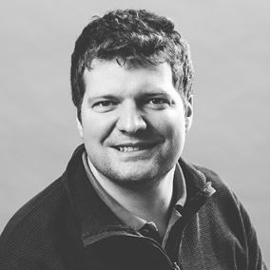Hello all, my name is Kurt Leadley and I’m here to make Nodeflix with some fellow developers. I’ve been doing sorts of programming now for the last 4 years professionally. I worked for 3 years at GlobalFoundries writing automation code with Google Apps Script. I currently work for a much more local company that makes websites named ADG Communications. I mainly work with a CRM (customer relationship management) system called CiviCRM. I do some front end jQuery as well, but most of the time I am scrubbing spreadsheet data with Google Apps Script and doing data imports / manipulation with MySQL. I also have some side projects that involve PHP and I am currently trying to finish up my Bachelor’s degree and learn the MEAN stack. Prior to all this tech stuff, I worked as a cook for 12 years.

Anyways, I’ve always loved making things, whether it is a website, some sort of cool automation code, veal stew, or as a child that new Lego set. I am also a big time sports fan and I like to incorporate sports into all of my coding ventures (when allowed). I love football and hockey mostly. I also play hockey, like to hike and bike. All of this stuff happens in upstate New York with my lovely wife Lauren.

**Wendy Portillo**

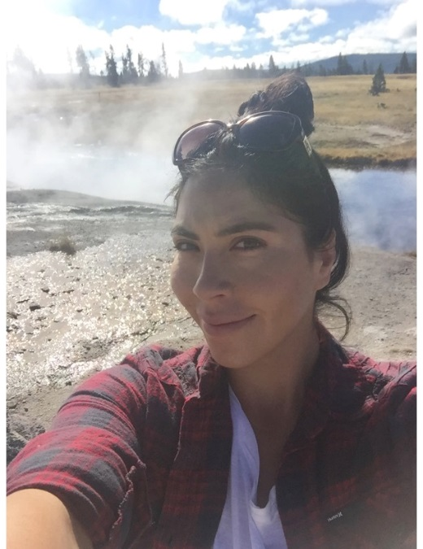Hi, my name is Wendy Portillo. I am one of the developers on this project. I am a curious self-driven designer with a strong passion for design and development of engaging user experiences. I thrive in creative ideas and engaging solutions across brand identity, print, packaging, and digital media. As a designer, I know that learning never stops and this is something that I embrace wholeheartedly. I am currently taking online degree program to gain hands-on experience in full stack web development, Bellevue University's Bachelor of Science in Web Development.  I’m always seeking new challenges and experiences. I love to come up with unique solutions to creative problems regardless of what medium I’m working in. My passion for helping others comes from the guidance my mentors and community have given me. Collaborating with others has allowed me opportunity to continue to grow as a designer. When I’m not designing, I’m either listening to audible, hiking, working my way to learn how to cook family recipes and indulging my love for seeing new places.

**Joshua Hughes**

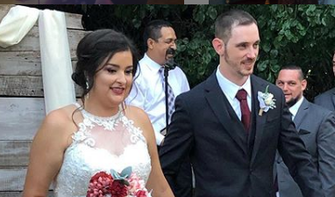 Hello all, my name Is Joshua Hughes. I Am currently working as a Support Engineer for PayPal. I recently Just got married to my beautiful wife Mariza. I enjoy hanging out with my two daughters, playing music, learning about God and any combination of the above things. I enjoy seeking out of the box solutions for common everyday problems, and when something gets in my mind, I generally cannot rest until it is addressed. I also enjoy working on cars and building things. I like learning new things and enjoy challenging myself to understand tough concepts. I speak Spanish fluently as a learned second language, and can play Drums, Guitar, bass, keyboard, and harmonica. I am eager and excited to work with this team to see how we can blend our creative styles to produce an epic and different streaming application for Nodeflix.

**Goals of website:**

The Goals of Nodeflix will be to be able to provide a streaming service that is different than other streaming services. TV shows, movies, documentaries, and prerecorded sporting events will be able to be accessed by any internet capable device. We will do this by offering three separate levels of membership in order to accommodate the most users possible. Each pricing/membership level will have its own unique benefits and features. The website will be designed be able to accommodate a few users on startup but maintain the same level of comfort with the system and platform with a large userbase.

**Core users:**

The core users of the NodeFlix website will be as follows:

* user who doesn’t like sports
* user who likes sports, but doesn’t need to record
* user who wants access to Premium channels
* user who doesn’t need to record
* user who doesn’t like commercials
* user who needs to record
* user who doesn’t mind commercials
* user who has a friend who wants to use NodeFlix
* Two-person family
* Group of three friends
* Group of four friends
* Family with a single child.
* Family with more than 2 active users

**User requirements:**

As a NodeFlix user, I need a menu and interface that is easy to understand and use.

As a NodeFlix user, I need to be able to easily access my content

As a NodeFlix user, I need to easily manage my payments

As a NodeFlix user, I need to be able to manage my profile easily

As a NodeFlix user, I need to be able to upgrade and downgrade my plans with ease.

**Developer requirements:**

**1.** As developers, we need to discuss any other sort of functionality this application may need (other than just providing 3 tiers of service, so that when we create a wireframe we do not forget any UI elements, causing us to change our design.

**2.** As developers, we need to then create a wireframe/s, so that we can have a vision of how our UI will look, what the workflows are and what all the different pages will be.

**3.** As developers, we need to come up with a comprehensive schema for our mongoDB, so that we are not scrapping a database build halfway through the project. Having the right database schema for our project from the start will help all other facets of the project moving forward.

**4.** As developers, we need to create a work plan so that we can split up the tasks and streamline the process. Leveraging the team members’ strengths will create a better application in a timely and cost effective manner.

**5.** As developers, we will need to implement the coding / development process and deliver a fully functional product back to NodeFlix, so that the customer is happy and we get paid.

Some of these implementation tasks include (NOT Limited to):

* Setting up a server environment
* installing node, mongo and any other dependency
* Creating all the pages, styling the pages, placing UI elements
* Front end of the line coding for UI elements
* Server side programming to communicate with mongoDB
* Creating an admin panel
* Testing
* More Testing
* Go Live

**Personas:**

